***Completed by Examiner:***

|  |  |
| --- | --- |
| **Date:** | |
| **Tread water for 2 minutes:** | **    ◻ Pass ◻ Fail** |
| **100 Meter Swim:** | **    ◻ Pass ◻ Fail** |
| **Examiner:** | |
| **Title:** | |

**NOVICE ROWER / COXSWAIN SWIM REQUIREMENT TEST FORM**

USRowing, which guides all crew clubs in the United States, requires each club authority to ensure that each member of its Crew has passed the required swimming examination before taking part in any rowing related water activity, competition, or practice. Experienced high school rowers in Virginia complete this requirement as part of their scholastic team registration. However novice rowers who have never been a part of another rowing club must complete this requirement before being eligible to participate in our Learn to Row camp.

**USRowing requires that each participant be able to:**

➢ **Tread water for 2 minutes, and**

➢ **Swim 100 meters, any stroke, with no time limit**

The examination needs to be passed only once in a student’s rowing career, and must be administered by an adult, 18 years or older, who is also a registered life guard, pool operator, or supervisor at a pool / RECenter. This individual cannot be a family member of the individual being tested.

***Completed by Athlete***:

|  |  |
| --- | --- |
| **Name (please print):** | |
| **School:** | |
| **Grade:** | **    ◻ 7 ◻ 8 ◻ 9 ◻ 10 ◻ 11 ◻ 12** |
| **Prior Crew Member:** | **◻ Yes (School _______________________ Years _________) ◻ No** |

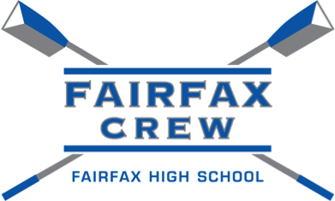

**ROWING CLUB**

**www.FairfaxCrew.org**